|  |  |
| --- | --- |
| EGC_Black | Student Name \_\_\_\_\_\_\_\_\_\_\_\_\_\_\_\_\_\_\_\_\_\_\_    **Eastern Goldfields College**  Mathematics Applications 2015  Test 6 (U2 T3) – Calculator Free1 |
|  | **Total Marks: 28 marks** |

**Time allowed: 28 minutes**

**No calculator or notes permitted for this section.**

***Answer all of the following questions. Show all working to obtain full marks.***

**Question 1** **(5 marks: 1, 2, 2)**

1. The random variable X is normally distributed with a mean of 45 and a standard deviation of 4.
   1. Determine P(X < 41).
   2. Given P(45 – *x* < X < 45 + *x*) = 0.997, find the value of *x*.
   3. Determine the quantile when the mass is 49g.

**Question 2 (4 marks)**

The diagram below shows two triangles: ΔABC is a right triangle and ΔXYZ is a non−right triangle. The diagram is not drawn to scale.

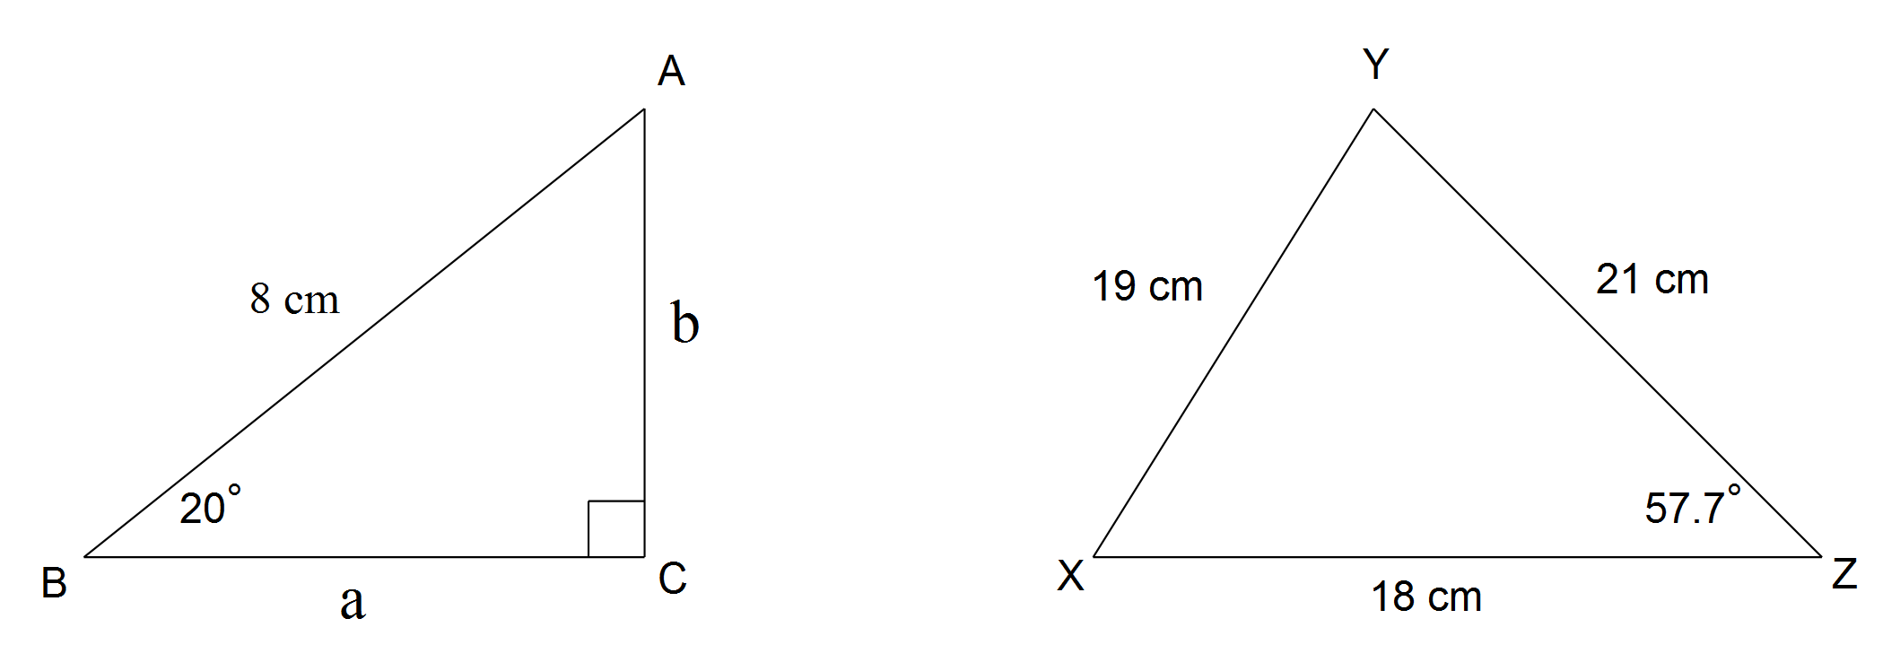

Consider the six statements (A, B, C, D, E and F) that follow. Two of the statements are correct, but four of these statements contain an error.

For each incorrect statement rewrite the statement to make it correct.

Statement A a2 − b2 = 64



Statement B tan70° =

Statement C ∠Y is the largest angle in ΔXYZ

Statement D Area ΔXYZ = ×18×19×sin57.7°



Statement E cosX =



Statement F sin20° =

**Question 3 (3 marks: 1, 1, 1)**

For each of the following, draw the triangle that corresponds with the given information:

(a) 

(b) 

(c) 

Question 4 (6 marks: 3, 3)

(a) In triangle, cm,  and .

Determine the length of side.

(b) In triangle,cm, cm and cm.

Determine the value of .

Question 5 (4 marks)

Solve the following pair of simultaneous equations:

$2x+3y=1$

$x-y=18$

Question 6 (6 marks: 5, 1)

a) The table below shows data about four different tests. Complete the table below:

|  |  |  |  |  |
| --- | --- | --- | --- | --- |
| **Test** | **Score** | **Standardised Score** | **Mean** | **Standard deviation** |
| 1 | 10 |  | 8 | 2 |
| 2 | 6 |  | 12 | 2 |
| 3 |  | 2 | 15 | 2.5 |
| 4 | 10 | -0.8 |  | 3 |

b) Order the student’s performance in the four tests from best to worst.

|  |  |
| --- | --- |
| EGC_Black | Student Name \_\_\_\_\_\_\_\_\_\_\_\_\_\_\_\_\_\_\_\_\_\_\_    **Eastern Goldfields College**  Mathematics Applications 2015  Test 6 (U2 T3) – Calculator Assumed1 |
|  | **Total Marks: 37 marks** |

**Time allowed: 38 minutes**

***Answer all of the following questions. Show all working to obtain full marks.***

**Question 1** **(10 marks: 2 each)**

1. Suppose a factory produces Freddo frogs, and they are normally distributed with a mean mass of 35g and a standard deviation of 2g.
   1. If the probability of a Freddo being greater than a mass of *q* is 0.8, find *q*

* 1. What is the probability that a Freddo has a mass of less than 38.5g?

0.25% of all the Freddo’s produced are discarded because they are underweight.

* 1. What is the lightest mass (to the nearest g) a Freddo can be before being discarded?
  2. If 2.5 million Freddo’s are produced per day, how many are of the correct mass and can be sold each day (assume exactly 0.25% are underweight)?
  3. The mass of a giant Freddo is normally distributed, with a standard deviation of 3g. If the probability of the mass being less than 42.5g is 0.8, what is the mean weight of a giant Freddo?

Question 2 (6 marks: 2, 2, 2)

In this diagram, all three vertices of the triangle lie on the circumference of a circle of radius 13cm and the diameter of the circle is the side BC. Side AB is 10cm long and side AC is 24cm.



(a) Use the cosine rule to show that the size of angle CAB is 90°.

(b) Calculate the size of angle ACB.

(c) Draw a line from O to A on the diagram above and then find the area of triangle AOC.

**Question 3: [6 marks: 2, 4]**

Ben and Holly each buy tickets for themselves and their families for the elf concert. Ben buys two child’s tickets and four adult tickets and he pays $24. Holly buys three children’s tickets and three adult tickets and she spends $21.

a) Write two equations in terms of, *c,* the price of a child’s ticket and, *a*, the price of an adult ticket, for what each Ben and Holly spent.

b) Solve your equations to determine the cost of each type of ticket.

**End of Calculator Section**